1)You are given an array prices where prices[i] is the price of a given stock on the ith day.
You want to maximize your profit by choosing a single day to buy one stock and choosing a different day in the future to sell that stock.
Return the maximum profit you can achieve from this transaction. If you cannot achieve any profit, return 0.

Example 1:
Input: prices = [7,1,5,3,6,4]Output: 5Explanation: Buy on day 2 (price = 1) and sell on day 5 (price = 6), profit = 6-1 = 5.
Note that buying on day 2 and selling on day 1 is not allowed because you must buy before you sell.
Example 2:
Input: prices = [7,6,4,3,1]Output: 0Explanation: In this case, no transactions are done and the max profit = 0.

Constraints:
- 1 <= prices.length <= 105
- 0 <= prices[i] <= 104

Code:
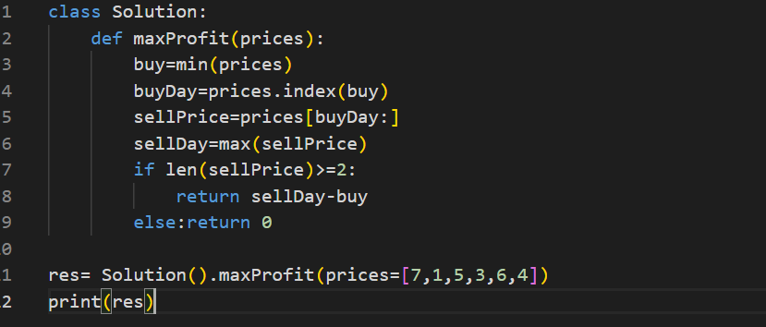

Output:
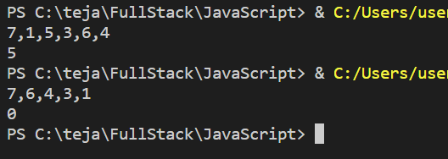

- Question:
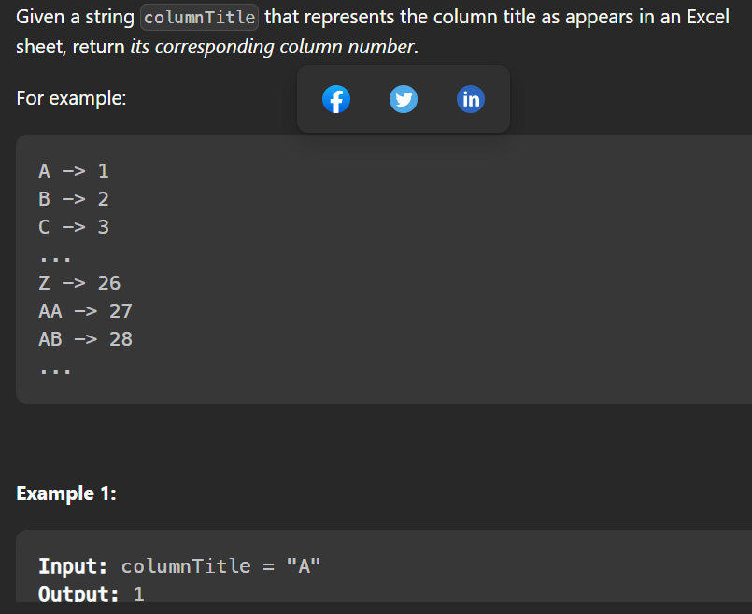
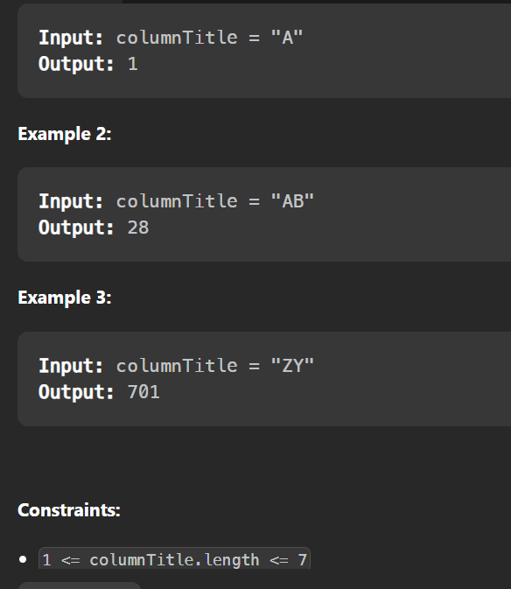
Code:
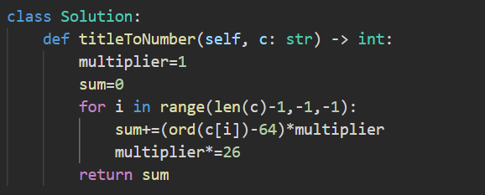

Output:
